Lab - 4 : Demonstration of Unix Commands: ln, nl, head, tail, sort, ƒind, uniq, tr, history, pipe, write, wall

Part: A
1. Perform the following Unix Commands: ln, nl, head, tail, sort, ƒind, uniq, tr, history, pipe, write,
wall

ln creates links between files.
ln creates hard links by default, or symbolic links if the -s (--symbolic) option is specified. When creating hard links, each TARGET must exist.
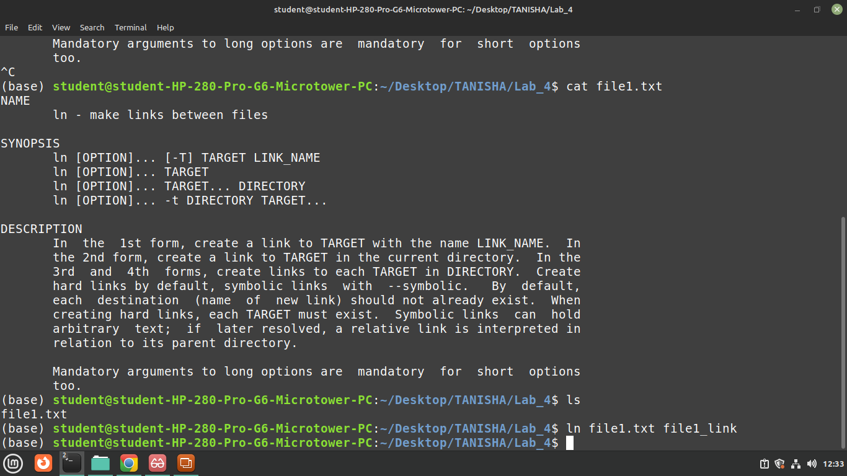

nl command numbers the lines in a file.
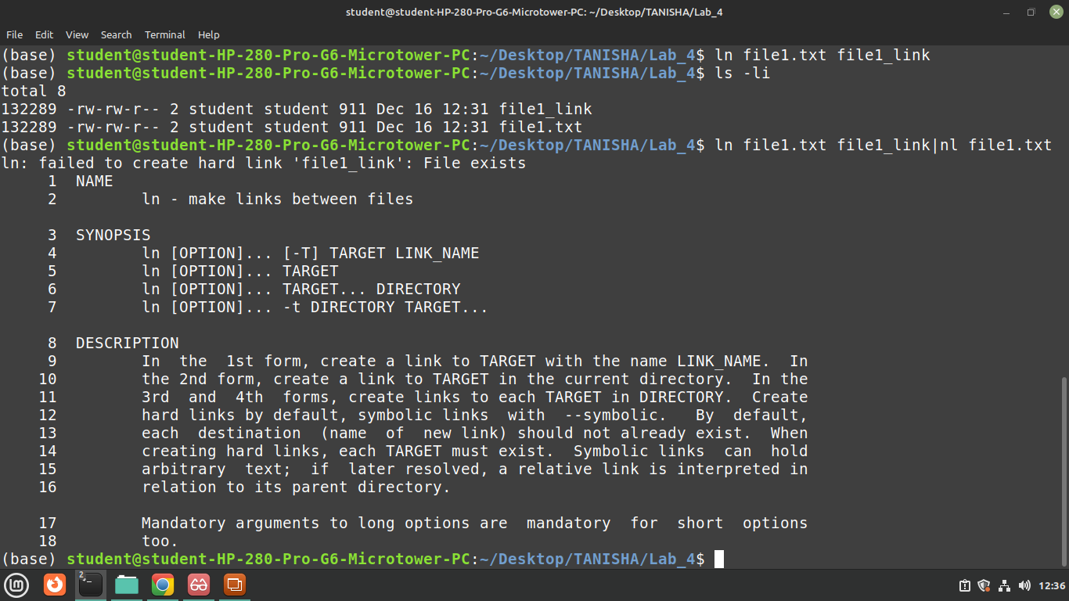

head makes it easy to output the first part (10 lines by default) of files.
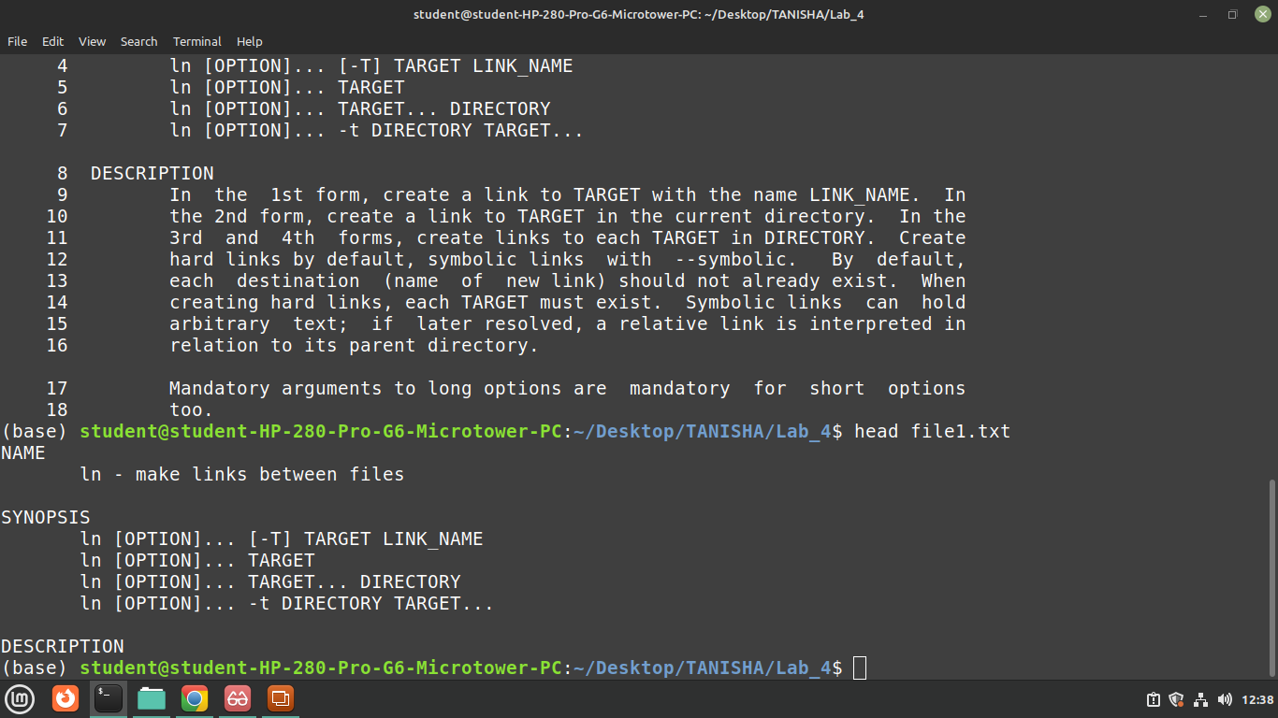
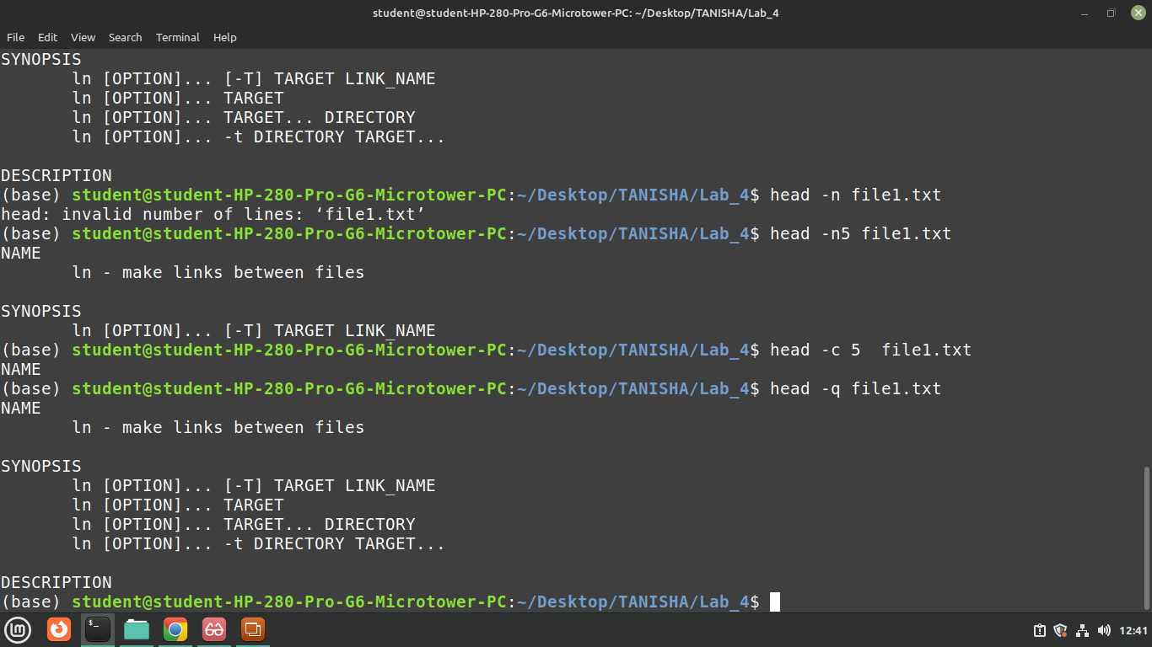

tail is a command which prints the last few number of lines (10 lines by default) of a certain file, then terminates.
Syntax :
tail [OPTION]... [FILE]...

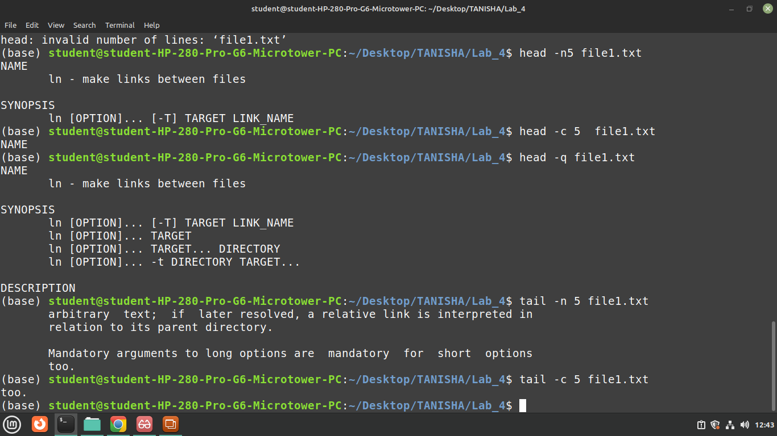

sort command is used to sort a file, arranging the records in a particular order.
By default, the sort command sorts file assuming the contents are ASCII. Using options in sort command, it can also be used to sort numerically.

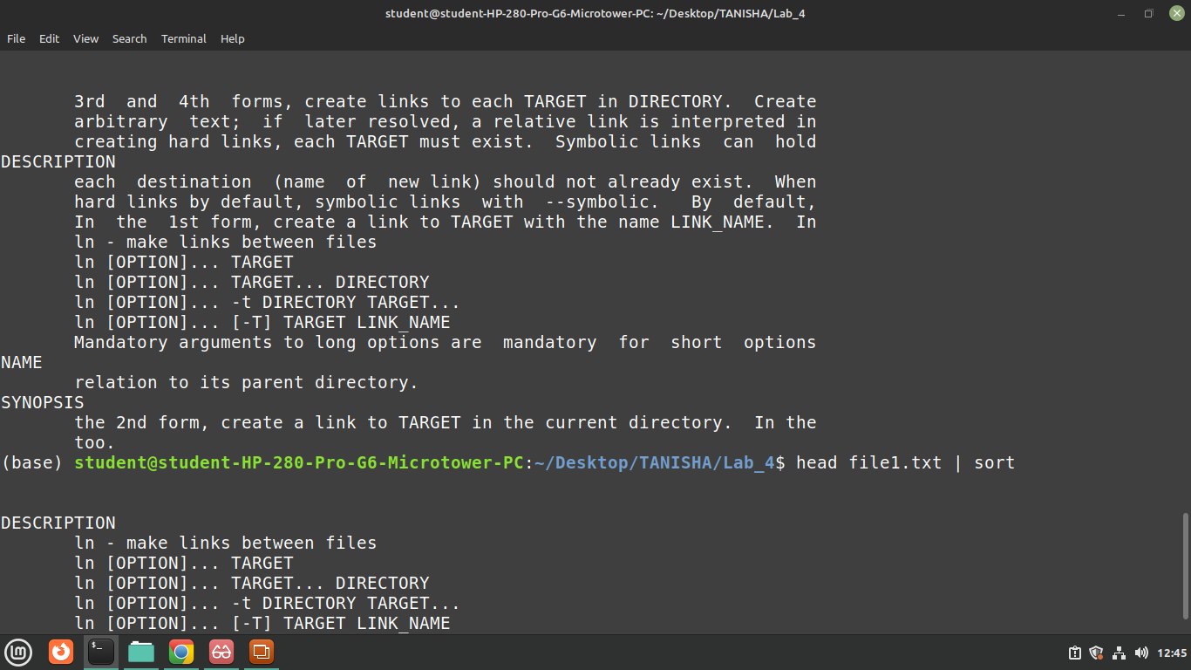
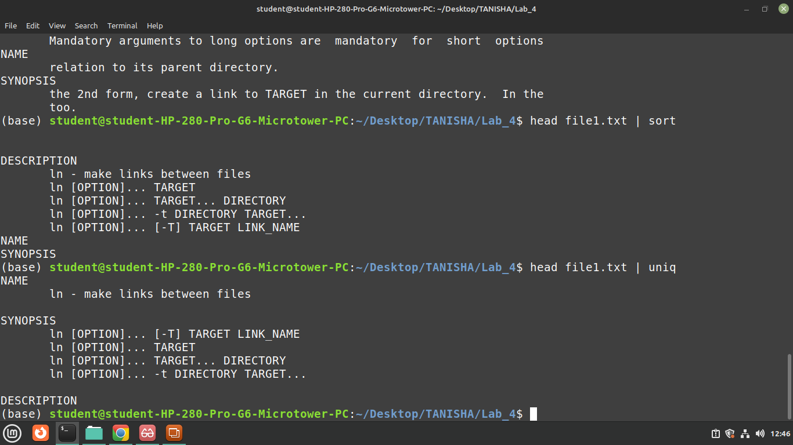

find
ind command searches for files in a directory hierarchy.
Syntax :
find [option] [path...] [expression]
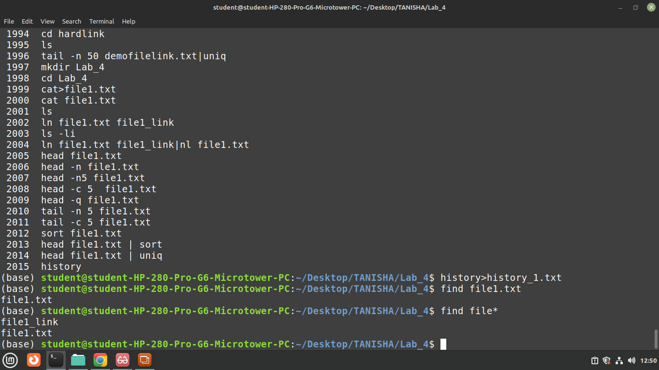

Part: B
1. Create a hard link named file_link to a file file.txt, then display the first 10 lines of file.txt with line
Numbers.

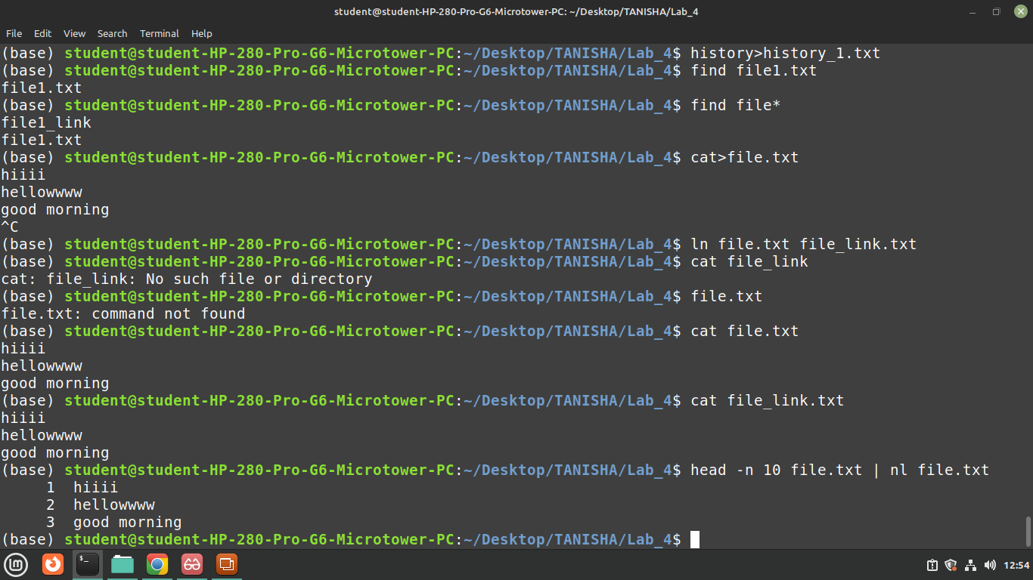

2. Display the last 20 lines of log.txt, sort the lines, and remove duplicate entries.
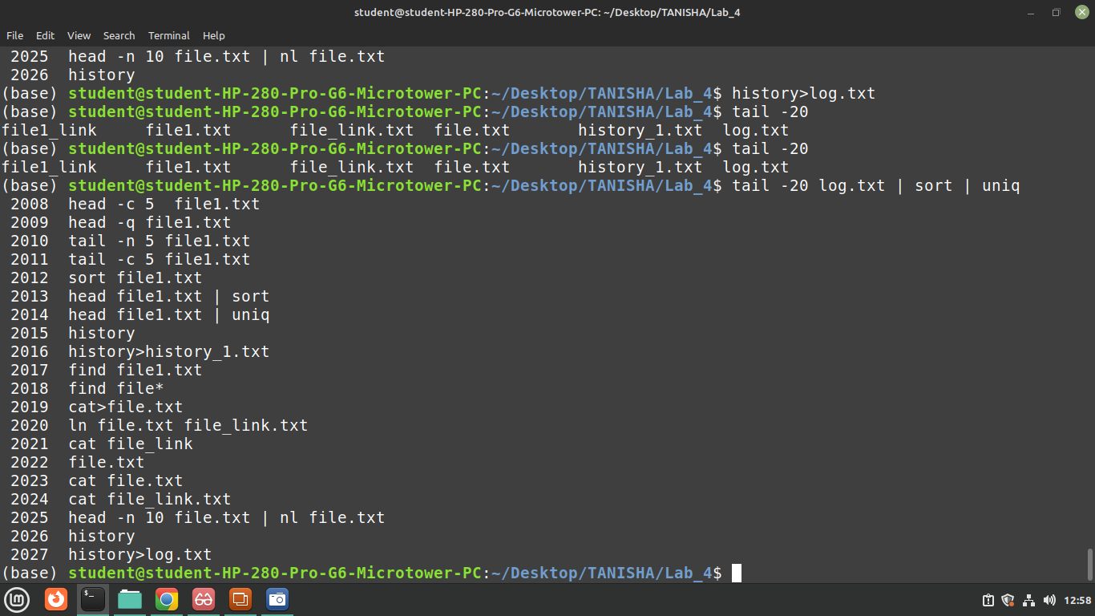

3. Find all .txt files in the current directory, display the first 5 lines of the search result, and send the
result to user john using write.

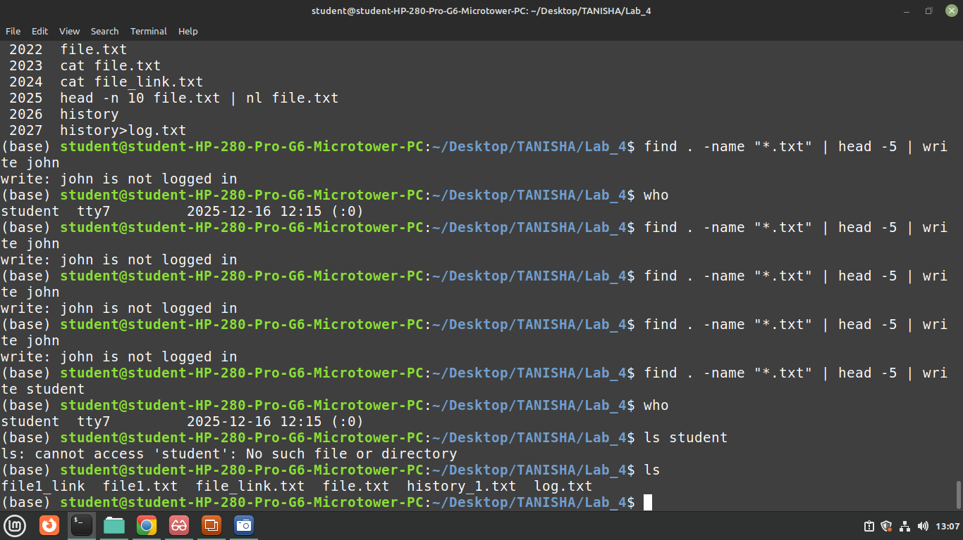

4. Display the last 10 commands from the command history and broadcast them to all logged-in
Users.

history 10 | wall

5. Add line numbers to the file data.txt, then sort the lines and remove duplicates.

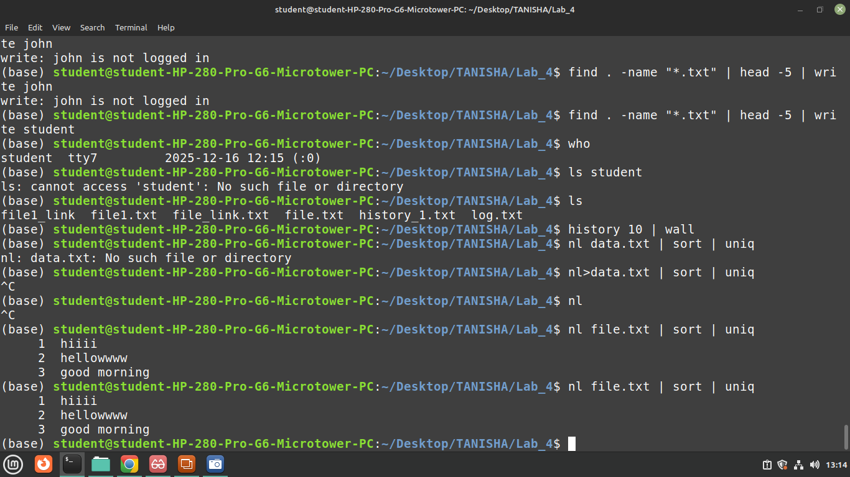

6. Create a symbolic link dir_link to a directory mydir, then find all .sh files in the directory and
broadcast the result to all users using wall.

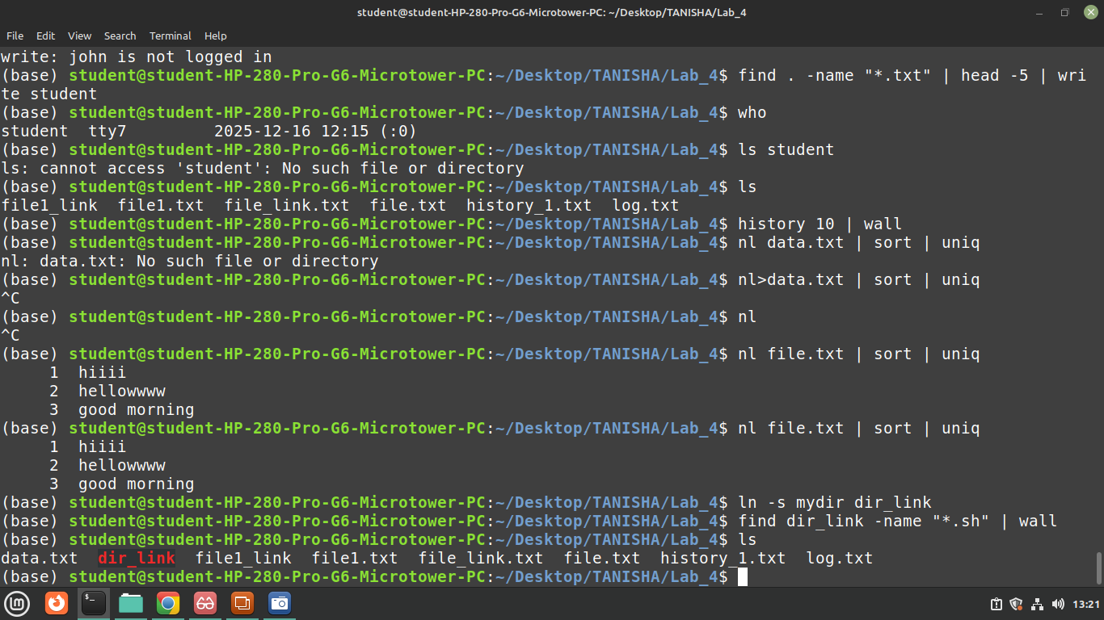

7. Display the first 5 lines and the last 5 lines of file.txt.
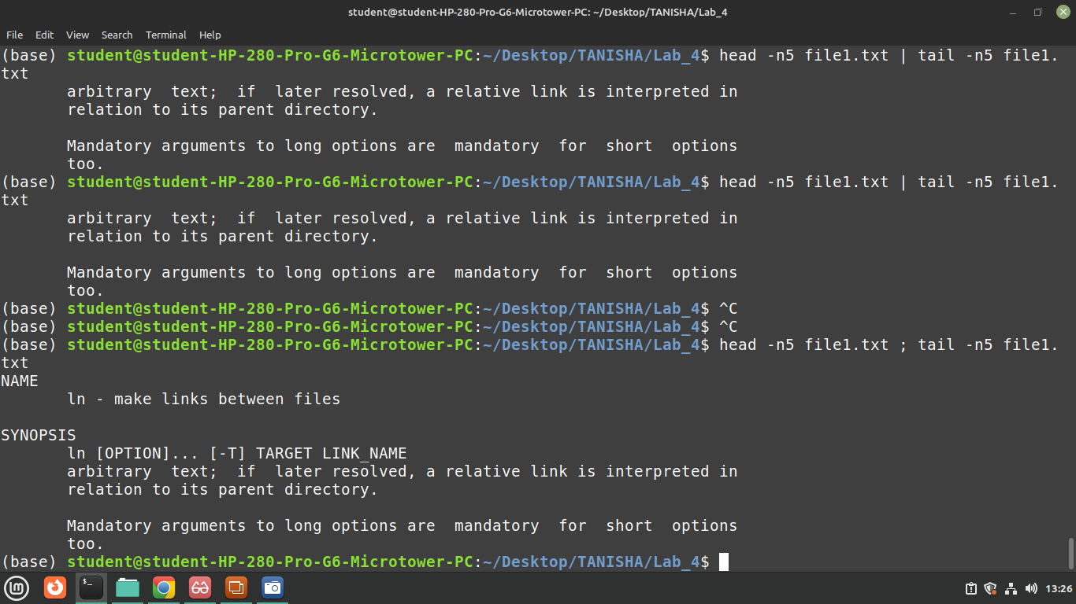

8. Find all .log files, sort them alphabetically, and remove duplicates if any.

Find -name “*.log” | sort | uniq

Part: C

1. Display the first 10 lines of input.txt, translate all lowercase letters to uppercase, and add line
Numbers.

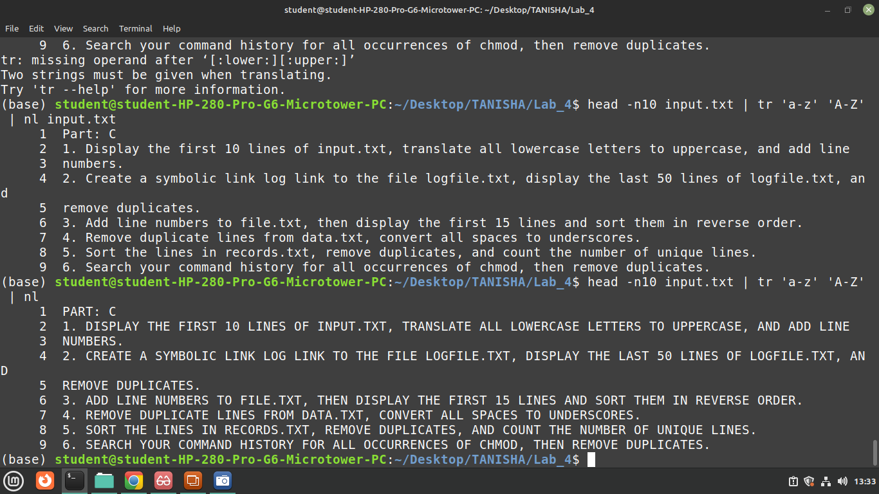

2. Create a symbolic link log link to the file logfile.txt, display the last 50 lines of logfile.txt, and
remove duplicates.
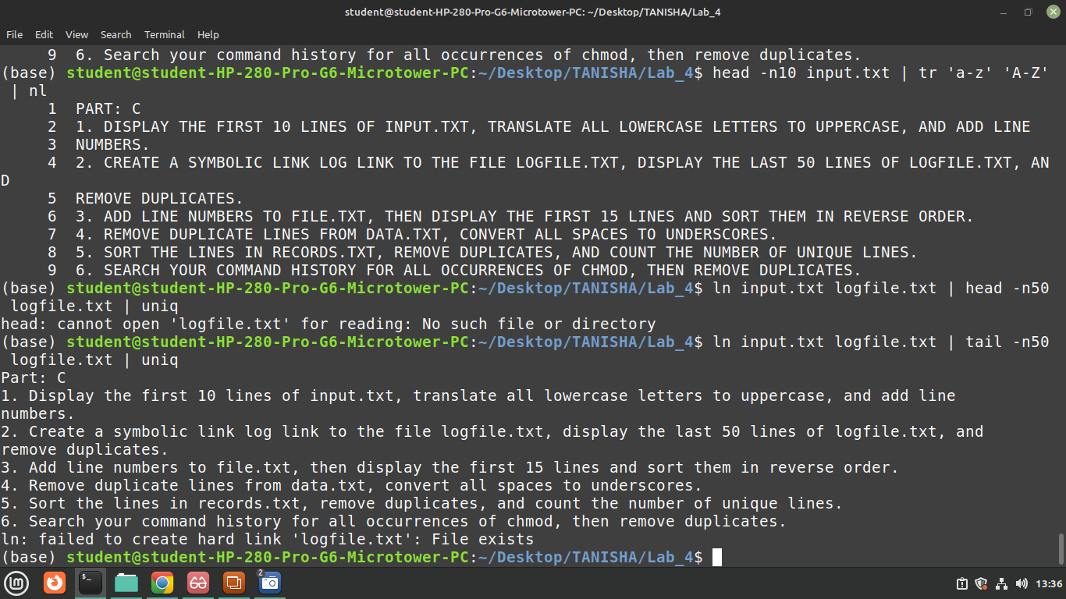

3. Add line numbers to file.txt, then display the first 15 lines and sort them in reverse order.
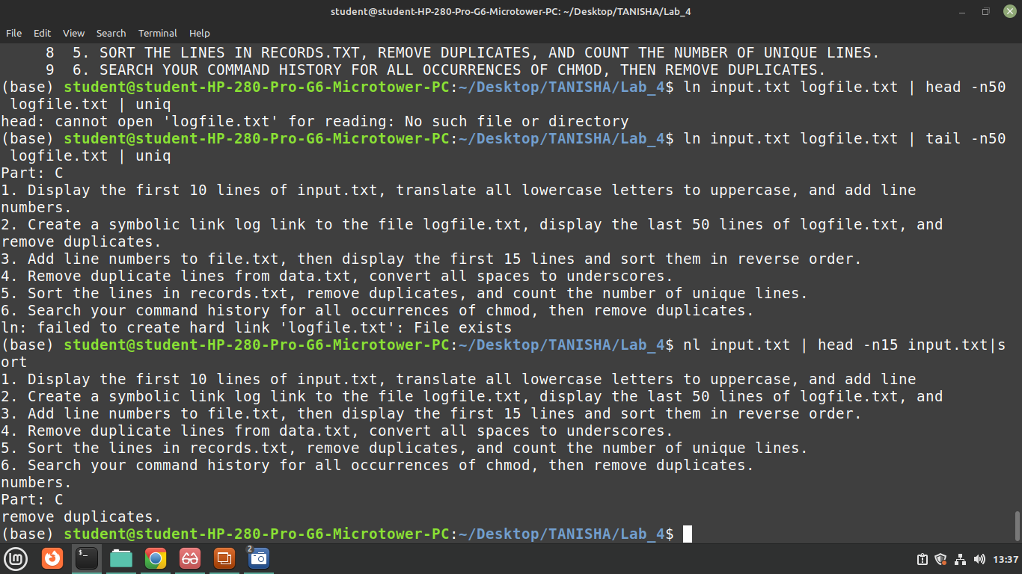

4. Remove duplicate lines from data.txt, convert all spaces to underscores.
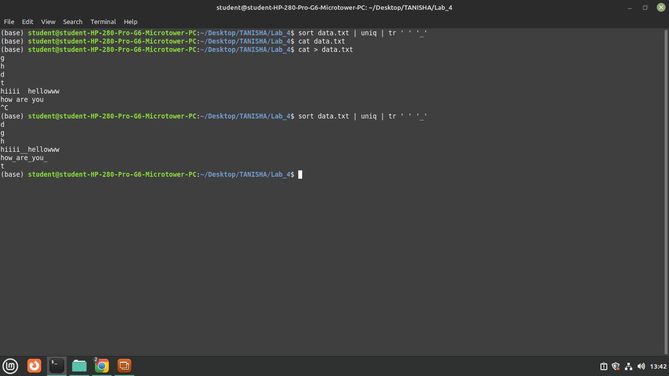
5. Sort the lines in records.txt, remove duplicates, and count the number of unique lines.
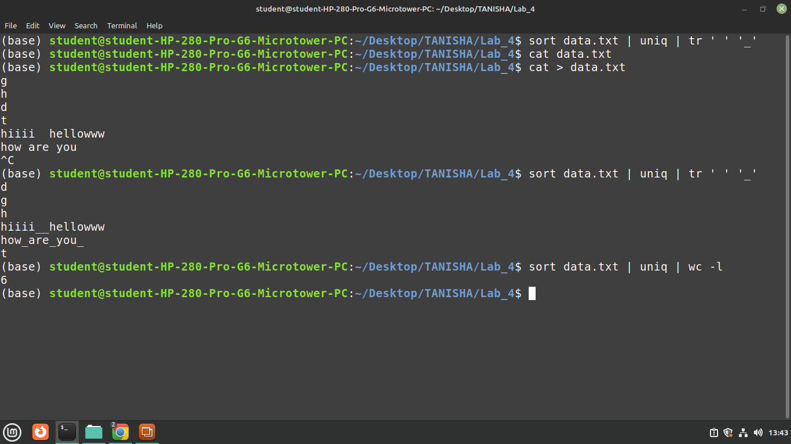

6. Search your command history for all occurrences of chmod, then remove duplicates.
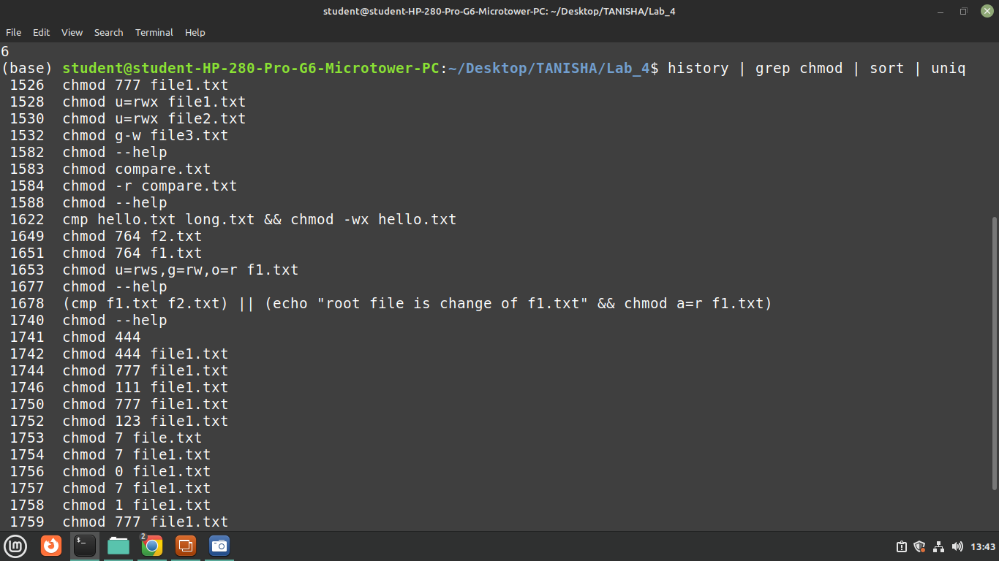
7. Display the first 10 lines of data.csv, then sort them in ascending order.

